TEA LEAF DISEASE PREDITION USING

DEEP LEARNING

TEAM MEMBERS

TEAM LEAD : MAHINDHA C

TEAM MEMBER 01: BALAJEEY R K

TEAM MEMBER 02 : HARISH KUMAR M

TABLE OF CONTENT

1. INTRODUCTION

1.1 Project Overview

1.2 Purpose

- IDEATION & PROPOSED SOLUTION

2.1 Problem Statement Definition

2.2 Empathy Map Canvas

2.3 Ideation & Brainstorming

2.4 Proposed Solution

- REQUIREMENT ANALYSIS

3.1 Functional requirement

3.2 Non-Functional requirements

4. PROJECT DESIGN

4.1 Data Flow Diagrams

4.2 Solution & Technical Architecture

- CODING & SOLUTIONING

5.1 Feature 1

5.2 Feature 2

- RESULTS

6.1 Performance Metrics

- ADVANTAGES & DISADVANTAGES

- CONCLUSION

- FUTURE SCOPE

- APPENDIX Source Code

1.INTRODUTION

1.1 PROJECT OVERVEIW:

Tea is an important economic crop. It is a widely consumed beverage, but tea production is often hampered by various diseases that affect yield and quality. Tea leaf diseases are caused by various pathogens and can lead to significant reductions in yield and quality. The use of chemical pesticides to control these diseases can have adverse effects on human health and the environment. An accurate and efficient system for predicting tea leaf diseases could greatly improve tea production and reduce reliance on chemical pesticides. The goal of this project is to develop a tea leaf disease prediction system using the VGG16 model and convolutional neural networks (CNN). The system will leverage deep learning techniques to automatically analyze images of tea leaves and classify them into different disease categories. By accurately identifying tea leaf diseases, farmers can take timely actions to prevent crop losses and ensure the health and productivity of their tea plantations. The system would be trained on a large dataset of tea plant images and environmental variables such as temperature, humidity, and rainfall. The images would be labeled with the corresponding tea leaf diseases present in the image. The VGG16 architecture would be used to extract features from the input images and then classify them into the appropriate disease category.

1.2 PURPOSE:

VGG16 is trained on a large dataset of tea leaf images, allowing it to learn complex patterns and features associated with different diseases. This enables the model to accurately distinguish between healthy leaves and those affected by various diseases, even detecting subtle visual cues that may go unnoticed by human observers. CNN models like VGG16 excel at hierarchical feature extraction, automatically learning relevant features at different levels of abstraction. This capability is especially useful in tea leaf disease prediction, as diseases can manifest in different ways, from discoloration and spots to deformations or lesions. By analyzing multiple layers of features, VGG16 can capture and interpret these diverse disease symptoms. The accurate identification and classification of tea leaf diseases using VGG16 and CNN have several practical implications. It enables early detection of diseases, allowing farmers to take prompt preventive measures to minimize crop losses. By targeting specific diseases, farmers can implement precise interventions such as targeted pesticide application, selective pruning, or choosing disease-resistant cultivars, reducing the need for broad-spectrum treatments and promoting sustainable agricultural practices.
2. IDEATION & PROPOSED SOLUTION

2.1 PROBLEM STATEMENT DEFINITION:

Tea is an important economic crop. It is a widely consumed beverage, but tea production is often hampered by various diseases that affect yield and quality. Tea leaf diseases are caused by various pathogens and can lead to significant reductions in yield and quality. The use of chemical pesticides to control these diseases can have adverse effects on human health and the environment. The problem is the lack of a reliable and scalable solution for tea leaf disease prediction. Manual inspection of tea leaves is labor-intensive and may not always yield accurate results, leading to delayed detection and ineffective control measures. Additionally, the diverse range of disease symptoms and variations in tea leaf appearance make it challenging for human observers to consistently identify and classify diseases accurately. An accurate and efficient system for predicting tea leaf diseases could greatly improve tea production and reduce reliance on chemical pesticides. Machine learning algorithms, such as deep learning, have shown promise in disease prediction in plants.

The goal of this project is to develop a deep learning-based system for tea leaf disease prediction that leverages advanced techniques such as convolutional neural networks (CNN). The system will be trained on a comprehensive dataset of tea leaf images, including healthy leaves as well as leaves affected by various diseases.
2.2 EMPATHY MAP CANVAS
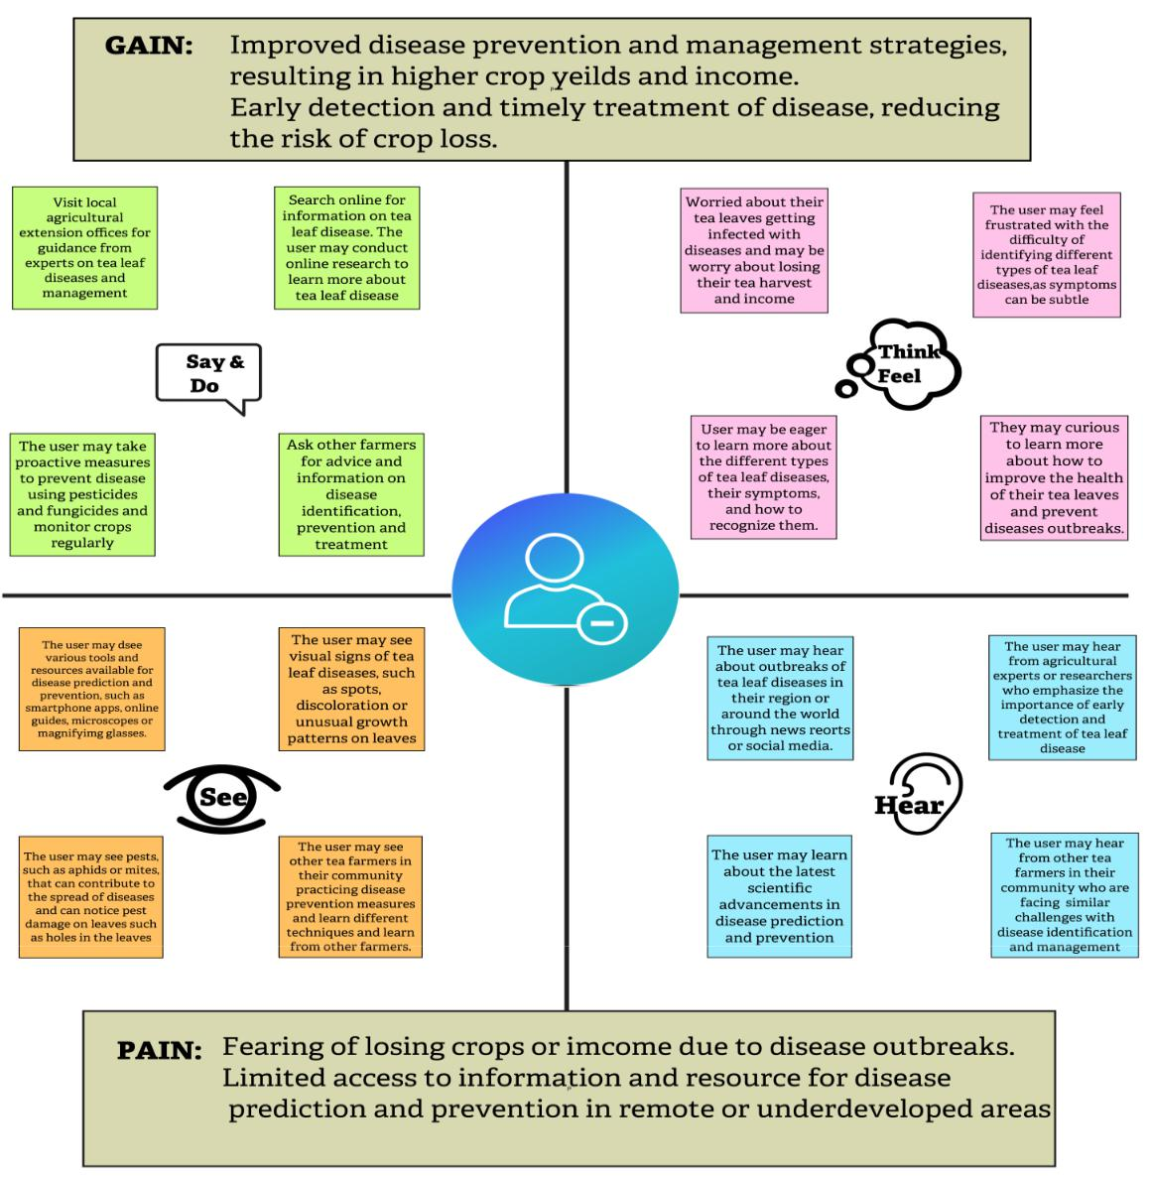
2.3 IDEATION & BRAINSTORMING:
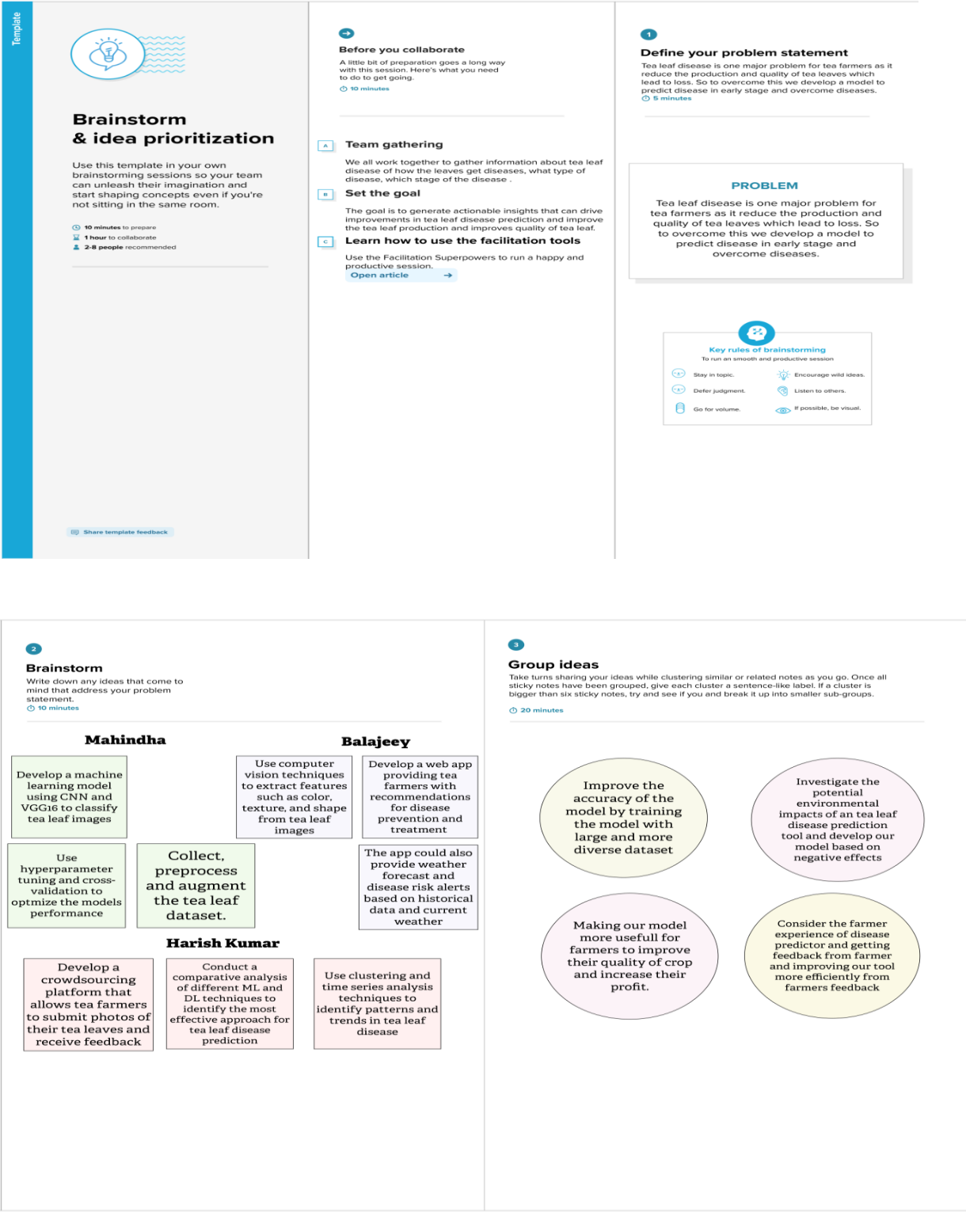
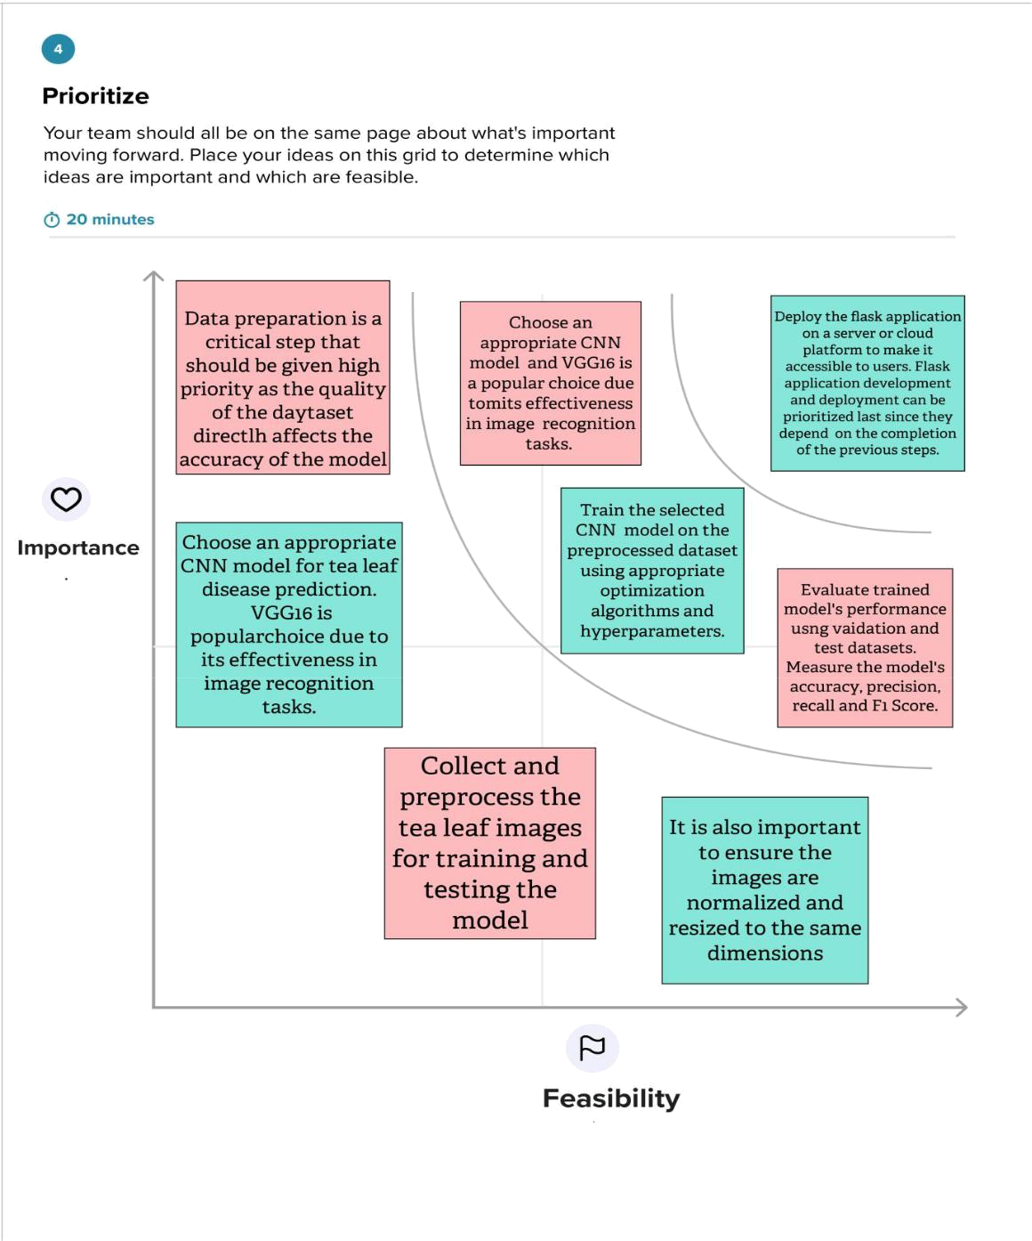
2.4 PROPOSED SOLUTION:

Dataset of tea leaf images should be collected, encompassing both healthy leaves and leaves affected by various diseases. It is crucial to ensure the dataset's diversity and representation across different disease categories. Each image in the dataset should be labeled with the corresponding disease type. Data preprocessing techniques are applied to standardize the dataset. This involves resizing the tea leaf images to a consistent resolution, normalizing pixel values, and augmenting the dataset through operations like rotation, flipping, and zooming. Augmentation helps in enhancing the dataset's diversity and reducing overfitting. The VGG16 model, a widely used CNN architecture, is then initialized. VGG16 is pre-trained on a large-scale dataset, such as ImageNet, and known for its ability to extract intricate features from images. By leveraging pre-trained weights, the model already possesses a strong understanding of general image features.To adapt the VGG16 model for tea leaf disease prediction, fine-tuning is performed. The initial layers, responsible for detecting basic features like edges and textures, are frozen to retain their learned weights. The remaining layers are unfrozen and trained on the tea leaf disease dataset. This way, the model learns disease-specific features while leveraging the powerful feature extraction capabilities of the pre-trained layers. Tea leaf disease prediction using CNNs and the VGG16 architecture offers an effective solution to automate the identification of tea leaf diseases. By leveraging the power of deep learning and transfer learning, this approach can enable accurate and efficient disease detection, leading to timely interventions and improved crop management in the tea industry.
3. REQUIREMENT ANALYSIS

3.1 FUNCTIONAL REQUIREMENT:

Following are the functional requirements of the proposed solution.

FR | Functional Requirement | Sub Requirement (Story / Sub-Task)
No. | (Epic)
FR-1 | User Registration | Registration through Form
 |  | Registration through Gmail
 |  | Registration through LinkedIN
FR-2
 | Tea Leaf Image | Image Upload Interface,
 | Upload | Image validation
FR-3
 | Data Collection and | Data Acquisition, Data Preprocessing
 | Preparation | Labelling and Annotation
FR-4
 | Model Architecture and | Model Selection ,Transfer Learning,
 | Training | Hyperparameter Tuning, Loss function Detection
FR-5
 | Model evaluation and | Test Dataset Preparation, Performance Metrices,
 | Validation | Model Validation ,Iterative Improvement
FR-6
 | Prediction and Interface | User Interface Design Real-Time Inference
 |  | Deployment

3.2 NON-FUNCTIONAL REQUIREMENTS:

Following are the non-functional requirements of the proposed solution.

FR No. | Non-Functional | Description
 | Requirement
NFR-1 | Usability | The system should be user-friendly and intuitive,
 |  | making it easy for tea industry professionals to
 |  | interact with and interpret the prediction results.
NFR-2 | Security | The system should have appropriate security
 |  | measures in place to protect the tea leaf data and
 |  | ensure the privacy and integrity of the
 |  | information.
NFR-3 | Reliability | The system should be highly reliable, ensuring
 |  | that it consistently provides accurate predictions
 |  | and operates without frequent errors or failures.
NFR-4 | Performance | The system should provide fast and accurate
 |  | predictions for tea leaf quality and characteristics,
 |  | ensuring minimal latency and response time.
NFR-5 | Availability | The tea leaf predictor system shall aim for a
 |  | target availability of at least 99% during peak
 |  | hours of tea industry operation, ensuring that it is
 |  | accessible to users for the majority of the time
 |  | and minimizing any potential impact on their
 |  | decision-making processes.
NFR-6 | Scalability | The system should be designed to handle a large
 |  | volume of data and be capable of scaling up to
 |  | accommodate increasing amounts of tea leaf data
 |  | as the system usage grows.

4. PROJECT DESIGN

4.1 DATA FLOW DIAGRAM:
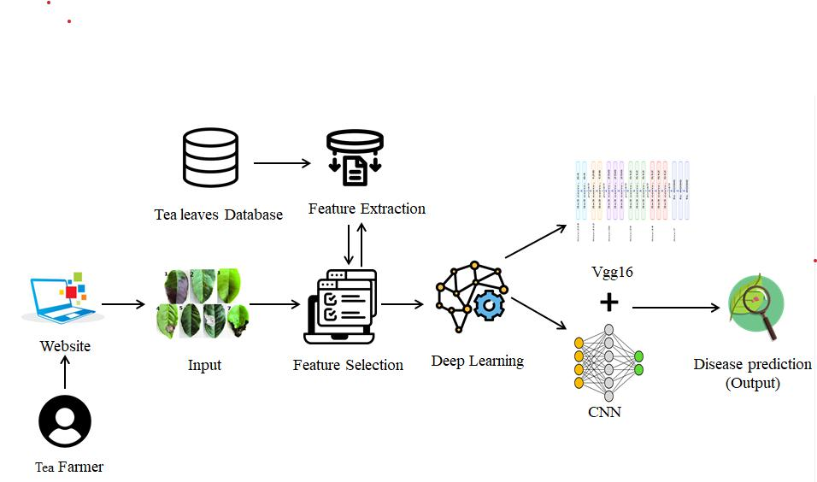

4.2 SOLUTION & TECHNICAL ARCHITECTURE:
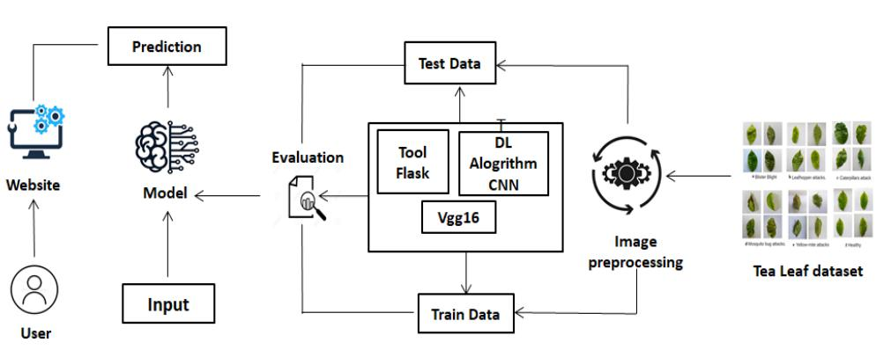
5.CODING & SOLUTIONING

Collecting Data and Processing it:
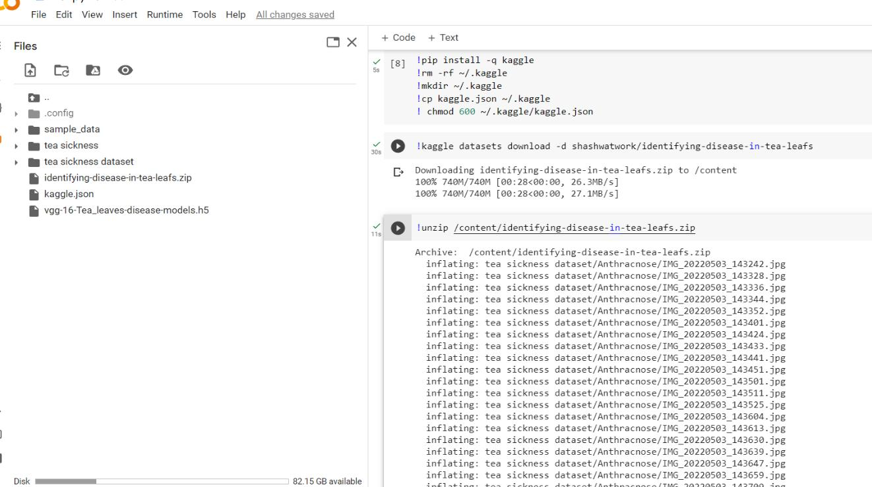

Training the Model using VGG16:
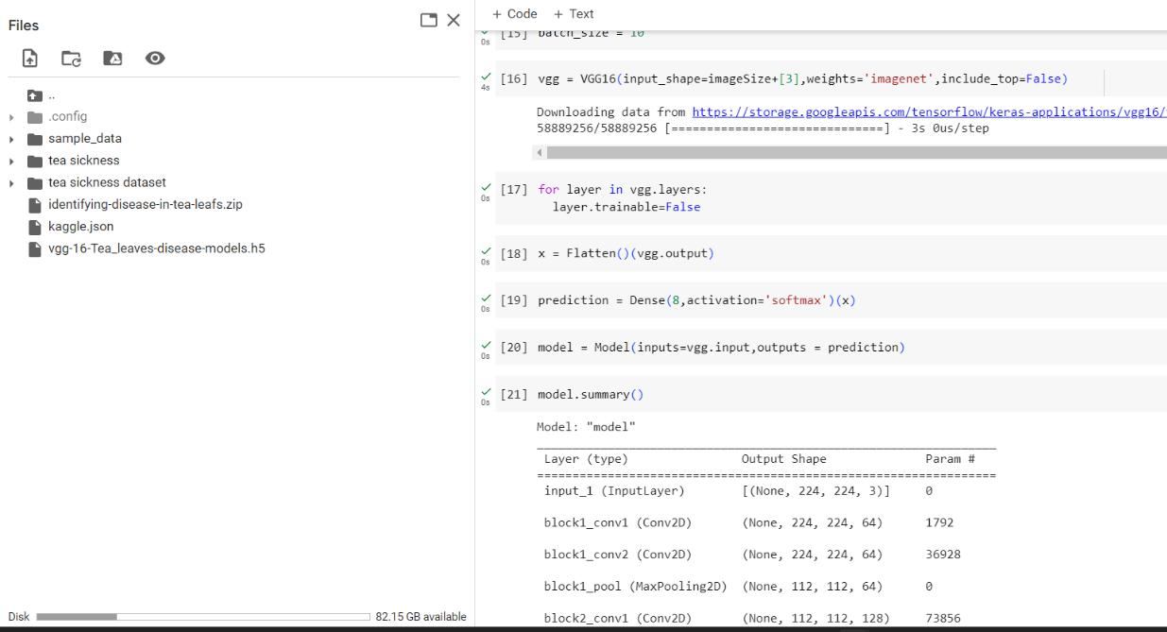

Model Configuration:
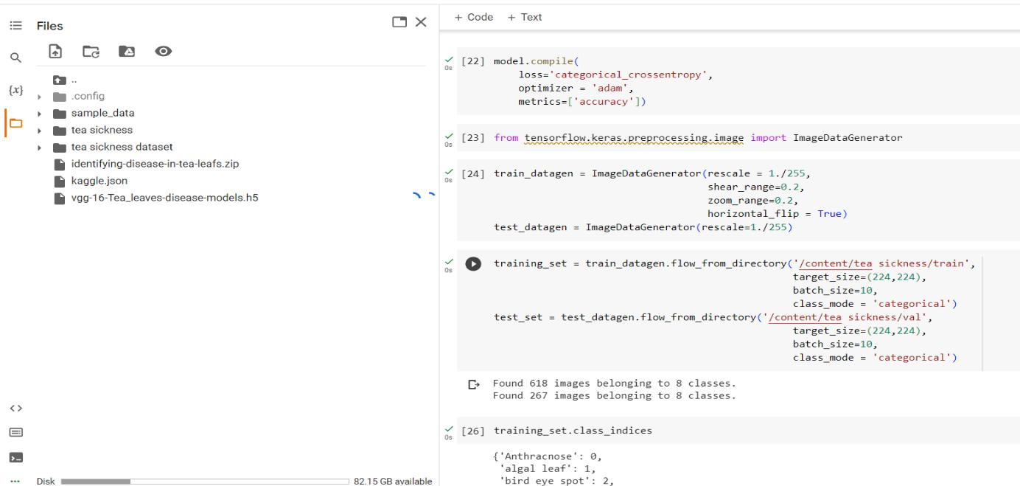
6. RESULTS

TEST ACCURACY:
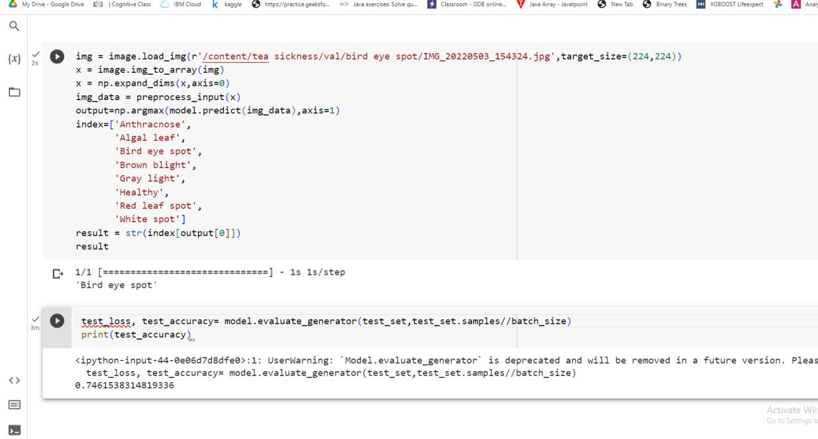

TRAIN ACCURACY:
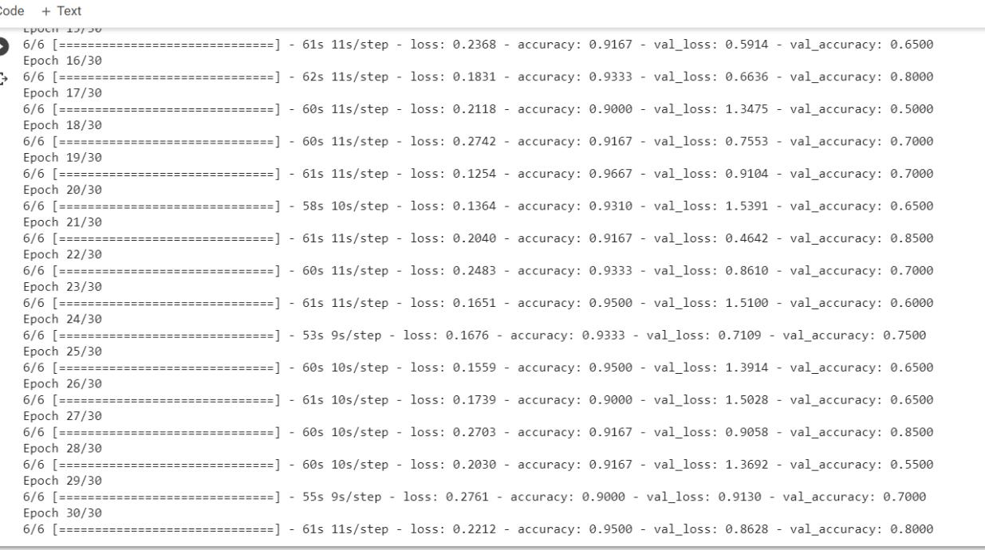

7. ADVANTAGES AND DISADVANTAGES

7.1 ADVANTAGES:

Accurate Disease Identification: The VGG16 architecture, with its deep convolutional layers, has shown excellent performance in image classification tasks. By leveraging CNNs and the VGG16 architecture, tea leaf disease prediction can achieve high accuracy in identifying various diseases, enabling timely interventions and effective crop management.

Handling Complex and Large-Scale Datasets: Tea leaf disease datasets can be large and diverse, containing numerous disease classes and variations. CNNs, with their ability to learn hierarchical representations, can effectively handle such complex datasets. The VGG16 architecture, with its deep layers and large receptive fields, can handle the scale and complexity of tea leaf disease prediction tasks.

Transfer Learning: The VGG16 model is pre-trained on a large-scale dataset like ImageNet, which helps it capture general image features effectively. By fine-tuning the model on a tea leaf disease dataset, transfer learning allows for faster convergence and improved performance, especially when the training dataset is limited.

Robust Feature Extraction: CNNs, including the VGG16 architecture, excel at automatically learning and extracting meaningful features from images. This capability is crucial in tea leaf disease prediction, as diseases often manifest as specific patterns, discoloration, or deformities on tea leaves. The VGG16 model's deep layers can capture these intricate disease-specific features, enhancing the model's ability to discriminate between healthy and diseased leaves.
7.2 DISADVANTAGE:

Overfitting: CNN models, including VGG16, are prone to overfitting, especially when the training dataset is limited or imbalanced. Overfitting occurs when the model memorizes the training examples instead of generalizing well to unseen data. Proper data augmentation, regularization techniques (such as dropout and weight decay), and careful hyperparameter tuning are essential to mitigate overfitting.

Need for Sufficient and Representative Data: The effectiveness of CNN models heavily relies on the availability of a comprehensive and representative tea leaf disease dataset. Collecting a diverse dataset with sufficient labeled examples for each disease category can be time-consuming and challenging. Insufficient or biased data may impact the model's performance and generalizability.

Computational Resources: The VGG16 architecture is a deep and complex model with a large number of parameters. Training and fine-tuning such a model can be computationally intensive and time-consuming, requiring substantial computational resources, especially if performed from scratch.

Interpretability: CNNs are considered black-box models, meaning they lack interpretability. Understanding the specific disease features learned by the model can be challenging. Interpreting the model's predictions solely based on the CNN's internal workings is difficult, which might limit its explainability and user trust.
8.CONCLUSION

In conclusion, tea leaf disease prediction using CNN with the VGG16 architecture is a promising approach for accurate identification of diseases in tea leaves. The VGG16 model, with its deep convolutional layers and transfer learning capabilities, enables robust feature extraction and captures disease-specific patterns effectively. By leveraging pre-trained weights, the model benefits from prior knowledge learned from large-scale datasets. However, there are challenges to consider. Training the VGG16 model can be computationally demanding, and overfitting may occur if not addressed properly. The interpretability of the model is limited, making it challenging to understand the specific disease features it learns. Additionally, the availability of a comprehensive and representative dataset is crucial for optimal performance. Despite these challenges, tea leaf disease prediction using CNN with VGG16 architecture offers the advantage of accurate disease identification, enabling timely interventions and improved crop management. Further research and advancements in model architecture, data collection, and interpretability can contribute to the continuous improvement of this approach in tea leaf disease prediction.
9.FUTURE SCOPE

The future scope of tea leaf disease prediction using CNN and VGG16 is highly promising. These technologies can revolutionize agriculture practices by accurately detecting and predicting diseases in tea plants. The key aspects of their future scope include improved accuracy, faster processing, enhanced dataset and model training, integration with IoT and remote sensing, and the development of user-friendly mobile applications. Advancements in CNN models like VGG16 will lead to increased accuracy in identifying and classifying tea leaf diseases. This will enable farmers to make informed decisions for disease control and prevention. Additionally, faster processing capabilities will allow for real-time or near real-time disease detection, enabling immediate action and minimizing the spread of diseases. The future scope also involves the use of larger and more comprehensive datasets for training CNN models. This will enhance their ability to detect rare and complex diseases accurately. Integration with IoT and remote sensing technologies will provide valuable environmental data, further improving disease prediction accuracy. Finally, the development of user-friendly mobile applications will empower farmers to utilize CNN-based models for disease prediction. These applications will provide a convenient tool for on-the-spot disease diagnosis and recommended actions, leading to timely interventions and improved tea plantation management.

Overall, the future scope of tea leaf disease prediction using CNN and VGG16 holds great promise for enhancing disease management, increasing crop yields, and ensuring sustainable agriculture practices in the tea industry.
10.APPENDIX

SOURCE CODE:

Vgg16 DL Model:

from tensorflow.keras.layers import Dense, Flatten, Input

from tensorflow.keras.models import Model

from tensorflow.keras.preprocessing import image

from tensorflow.keras.preprocessing.image import ImageDataGenerator, load_img

from tensorflow.keras.applications.vgg16 import VGG16, preprocess_input

from glob import glob

import numpy as np

import matplotlib.pyplot as plt

pip install split-folders

import splitfolders

!pip install -q kaggle

!rm -rf ~/.kaggle

!mkdir ~/.kaggle

!cp kaggle.json ~/.kaggle

- chmod 600 ~/.kaggle/kaggle.json

!kaggle datasets download -d shashwatwork/identifying-disease-in-tea-leafs

input_folder = '/content/tea sickness dataset'

splitfolders.ratio(input_folder,output='tea sickness',seed=42,ratio=(.7,.3),group_prefix=None)

imageSize = [224,224]

img_width = 224

img_height = 224

num_classes = 8

batch_size = 10

vgg = VGG16(input_shape=imageSize+[3],weights='imagenet',include_top=False)

for layer in vgg.layers:

layer.trainable=False

x = Flatten()(vgg.output)

prediction = Dense(8,activation='softmax')(x)

model = Model(inputs=vgg.input,outputs = prediction)

model.summary()

model.compile(

loss='categorical_crossentropy',

optimizer = 'adam',

metrics=['accuracy'])

from tensorflow.keras.preprocessing.image import ImageDataGenerator train_datagen = ImageDataGenerator(rescale = 1./255,

shear_range=0.2,
zoom_range=0.2,

horizontal_flip = True)

test_datagen = ImageDataGenerator(rescale=1./255)

training_set = train_datagen.flow_from_directory('/content/tea sickness/train', target_size=(224,224),

batch_size=10,

class_mode = 'categorical')

test_set = test_datagen.flow_from_directory('/content/tea sickness/val',

target_size=(224,224),

batch_size=10,

class_mode = 'categorical')

training_set.class_indices

- = model.fit_generator( training_set, validation_data=test_set, epochs = 30,

steps_per_epoch=len(training_set)//10,

validation_steps=len(test_set)//10)

from tensorflow.keras.models import load_model

from tensorflow.keras.preprocessing import image

model.save('vgg-16-Tea_leaves-disease-models.h5') model=load_model('vgg-16-Tea_leaves-disease-models.h5') img = image.load_img(r'/content/tea sickness/val/bird eye spot/IMG_20220503_154324.jpg',target_size=(224,224))

- = image.img_to_array(img)

- = np.expand_dims(x,axis=0) img_data = preprocess_input(x) output=np.argmax(model.predict(img_data),axis=1) index=['Anthracnose',

'Algal leaf', 'Bird eye spot', 'Brown blight', 'Gray light', 'Healthy', 'Red leaf spot', 'White spot']
result = str(index[output[0]]) result

test_loss, test_accuracy= model.evaluate_generator(test_set,test_set.samples//batch_size) print(test_accuracy)

Flask Connection: App.py:

from flask import Flask, render_template, request

import numpy as np

from tensorflow.keras.models import load_model

from tensorflow.keras.preprocessing import image

from tensorflow.keras.applications.vgg16 import preprocess_input model = load_model("vgg16.hdf5")

app = Flask(__name__)

@app.route("/")

def home():

return render_template("index.html")

@app.route("/about")

def about():

return render_template("about.html")

@app.route("/teahome")

def teahome():

return render_template("teahome.html")

@app.route("/tearesult", methods=["GET","POST"])

def tearesult():

img = image.load_img(request.form["Submit"])

- = image.img_to_array(img)

- = np.expand_dims(x,axis=0) img_data = preprocess_input(x) output=np.argmax(model.predict(img_data),axis=1) index=['Anthracnose',

'Algal leaf', 'Bird eye spot', 'Brown blight', 'Gray light', 'Healthy', 'Red leaf spot', 'White spot']

result = str(index[output[0]]) print(result)

return render_template("tearesult.html")

if __name__ == "__main__":

app.run(debug=True)

Project Video Demo Link:

https://drive.google.com/file/d/1lcQcLV4tv3x9iPrLpL3C1nEEa9bYBSjd/vie w?usp=sharing

GitHub:

https://github.com/naanmudhalvan-SI/PBL-NT-GP-12474-1682750609

